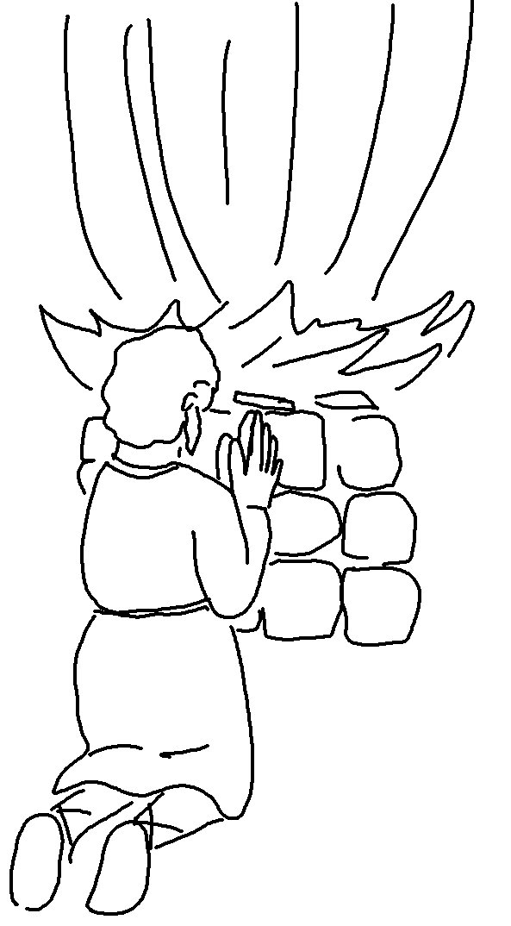
"The Lord—He is God! "
1 Kings 18:39_{NLT}

